All Children’s Integrated Primary School

FIRE SAFETY POLICY

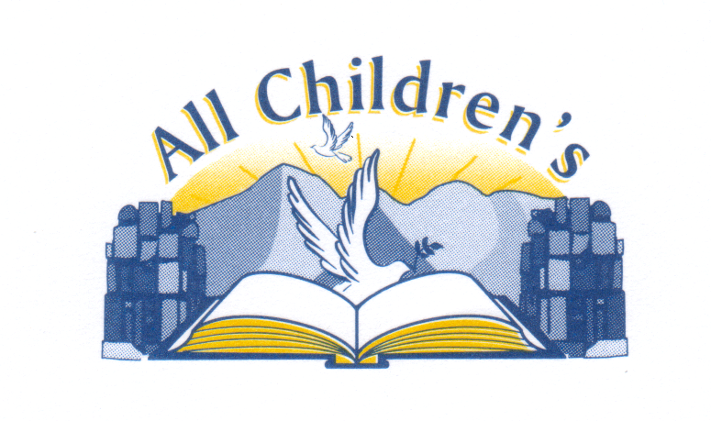
To be reviewed 2025-2026

FIRE SAFETY POLICY STATEMENT

Premises Name: All Children’s IPS

This Fire Safety Policy Statement has been prepared by Jon Beattie as the Appropriate Person (AP) for All Children’s IPS

The purpose of this Statement is to ensure the safety, from Fire, of all ‘relevant persons’ on, in or in the vicinity of the premises. ‘Relevant persons’ includes all members of staff, pupils, parents, visitors, volunteers, contractors, suppliers and statutory agencies who may be working in, or visiting the premises. This will be achieved by effective planning, organisation, control, monitoring, and review of the preventive and protective measures.

This Fire Safety Policy Statement also ensures All Children’s IPS complies with the legal obligations of The Fire and Rescue Services (Northern Ireland) Order 2006 and The Fire Safety Regulations (Northern Ireland) 2010, both of which are enforced by the Northern Ireland Fire and Rescue Service (NIFRS).

This Policy Statement will be used to ensure the provision of suitable and sufficient general Fire precautions, assessment of risk and management of necessary Fire safety arrangements.
As such, the following will be provided:

- The Premises Fire Safety Officer will be responsible for assisting the AP in carrying out their duties under the relevant legislation.

- A suitable and sufficient Fire Risk Assessment (FRA) will be prepared, regularly reviewed, and its significant findings acted upon.

- A suitable and sufficient Emergency Evacuation Plan will be prepared, regularly reviewed, and practised by the carrying out of Fire drills at least once per term.

- All relevant persons will be trained to satisfactorily carry out the requirements of the Emergency Evacuation Plan, take part in regular Fire drills and fulfil any other necessary actions to comply with the legislation.

- All relevant persons will be provided with comprehensible and relevant information regarding the risks identified from the FRA and any other notification of risk highlighted by other relevant persons, the preventative and protective measures, the Emergency Evacuation Plan, and the identities of persons nominated to carry out the duties of the AP.

- The employer of any employees from an outside undertaking and any other persons working on the premises will be provided with the same information as the relevant persons.

- All necessary systems required as part of the general Fire precautions (or other general systems or appliances required to be satisfactorily maintained to prevent the likelihood of Fire) will be tested and maintained in accordance with the relevant code of practice.

- Full records of these measures will be kept and made available for audit by the Northern Ireland Fire & Rescue Service (NIFRS) as required.

